1)

2)

3)

1. When there is a push in any keys, the output data will also change. We used PB 0-3 as output and PB 4-7 as inputs to be able to do that we connected R 1-4 to PB 0-3 and L 1-4 to PB 4-7. We checked if the input pins are changed, and if they don’t, it means there are no pushed buttons.

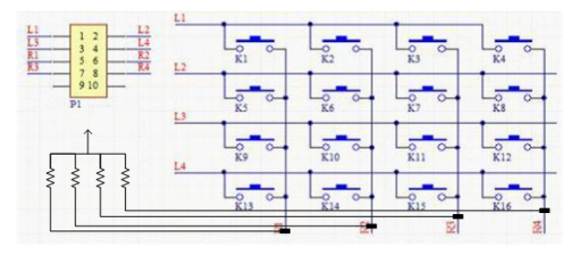

1. If there is a button pressed, it will go to COLM1, COLM2, COLM3, and COLM4. After that input will be read again. If the input is changed that means the key is released.
2. We shifted right the input and determined which COLM it belongs to. After that by compering the values of output we determined the ROW of the key.
3. If we don’t eliminate the bouncing effect, the results will be not acceptable. Results will be undetermined if we don’t add any delay. To overcome this situation, we add a delay and after reading it will read again and checks if there is a change in data and continue to do the rest of the code.

